----------Install postgresql DB-----------

1) sudo add-apt-repository ppa:timescale/timescaledb-ppa

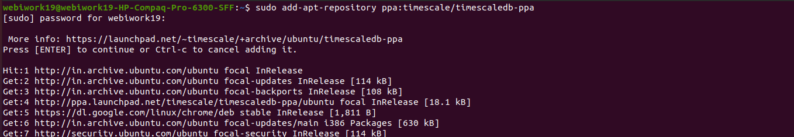
2) sudo apt update

3) sudo apt install timescaledb-postgresql-12

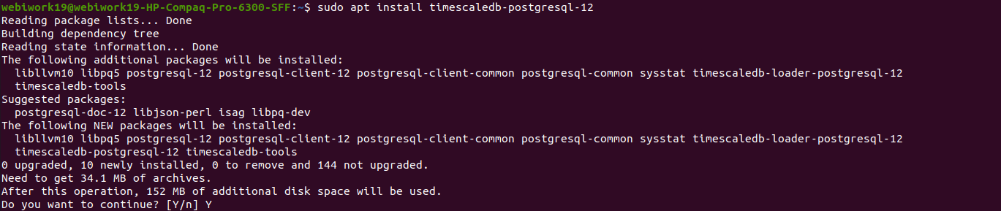

------Configuring TimescaleDB--------

1) sudo timescaledb-tune
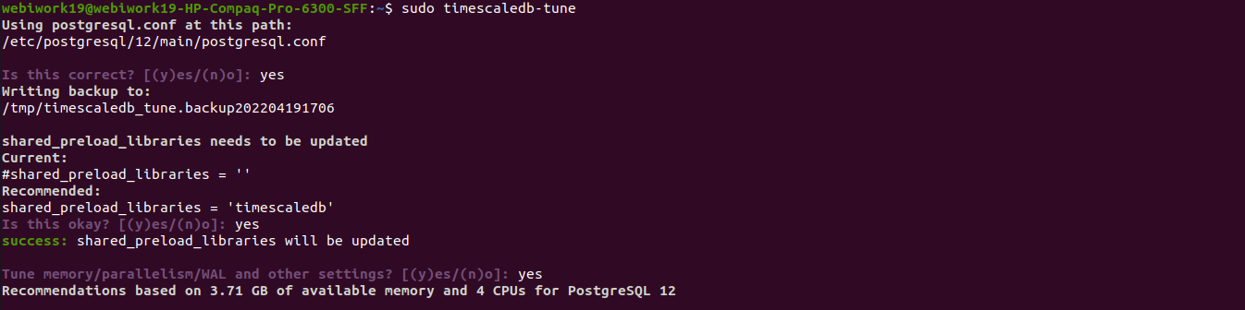

2) sudo timescaledb-tune --quiet –yes

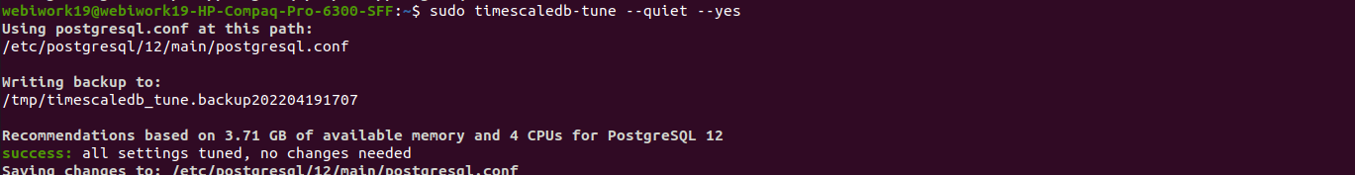
3) sudo systemctl restart postgresql.service
4) sudo systemctl status postgresql.service //----check it is in active state
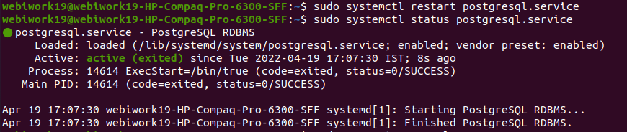

-------Creating a New Database and Hypertable--------
1) sudo -u postgres psql
2 ) CREATE DATABASE timeseries;
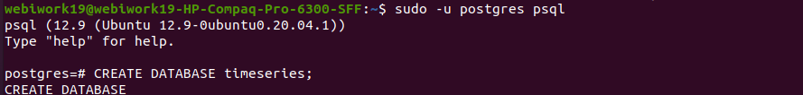

3) \c timeseries
4) CREATE EXTENSION IF NOT EXISTS timescaledb CASCADE;

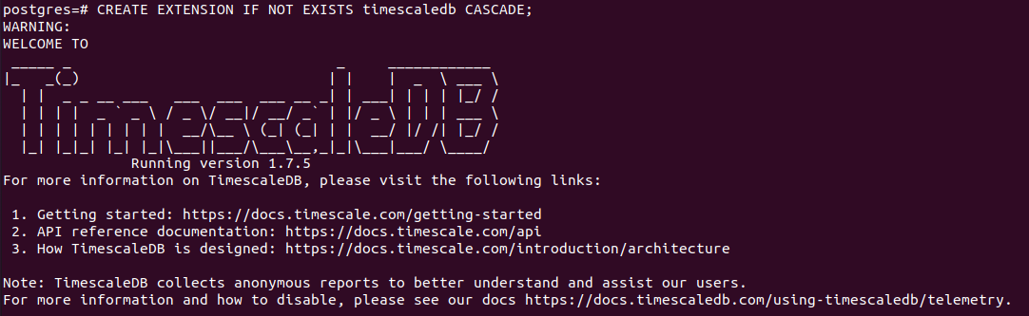

---------Create Table----------
CREATE TABLE conditions (
time TIMESTAMP WITH TIME ZONE NOT NULL,
device_id TEXT,
temperature NUMERIC,
humidity NUMERIC
);

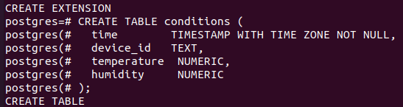

--------Create Hypertable--------

SELECT create_hypertable('conditions', 'time');

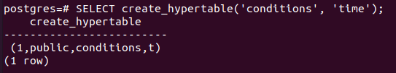

----------For Reference follow below link-----------

https://www.digitalocean.com/community/tutorials/how-to-install-and-use-timescaledb-on-ubuntu-20-04

------------Postgres Configuration---------------

* create user ->
1) create user <username> with encrypted password 'password';

* give privilege to user access to Db ->

2) grant all privileges on database <database_name> to <username>;

* grant permission to create Database ->

3) ALTER USER <username> CREATEDB;

* grant permission to create role ->

4)ALTER USER <username> CREATEDB CREATEROLE;

* root permission ->

1) \du
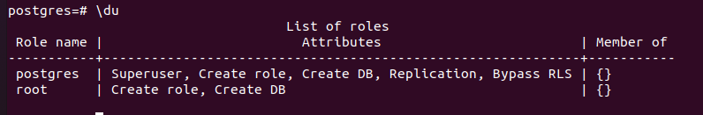

* remote configuration ->

1) sudo nano /etc/postgresql/12/main/pg_hba.conf //hold
// add your ip of machine and remote machine (IP protected)

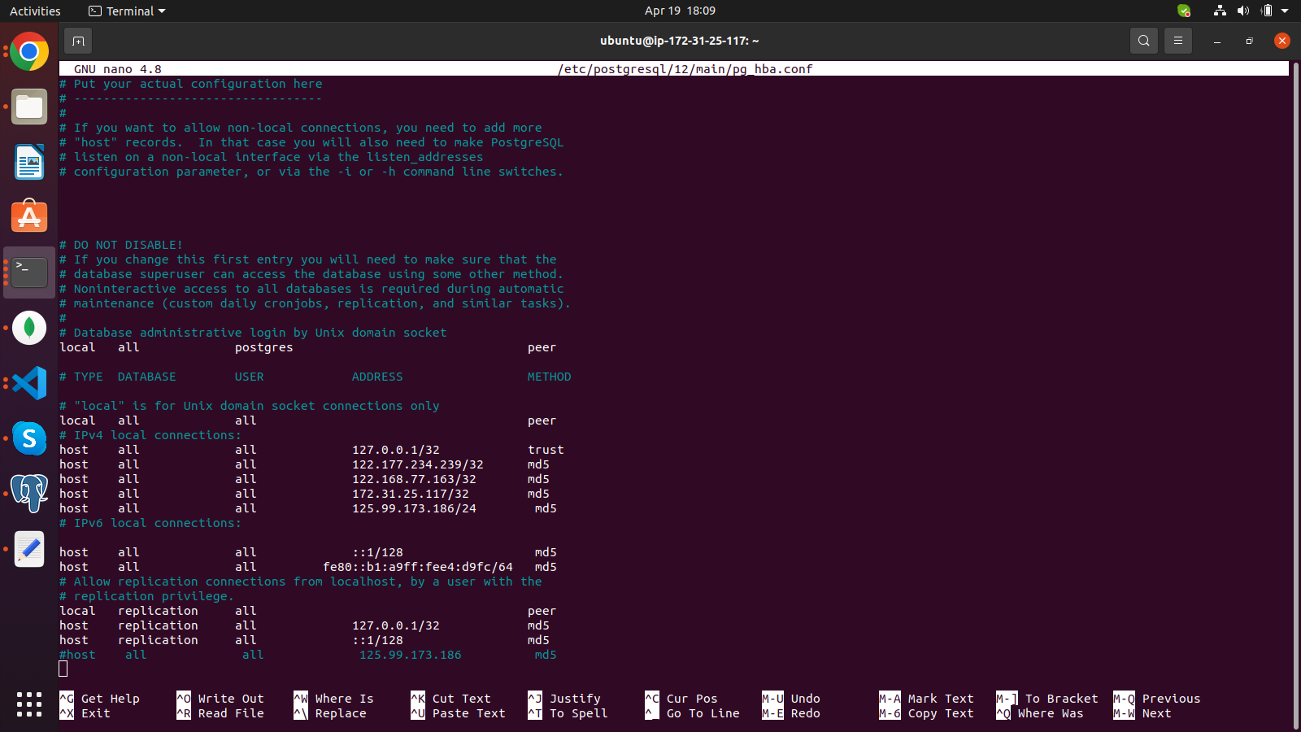

2) sudo nano /etc/postgresql/12/main/postgresql.conf

// you can change listen_address and port

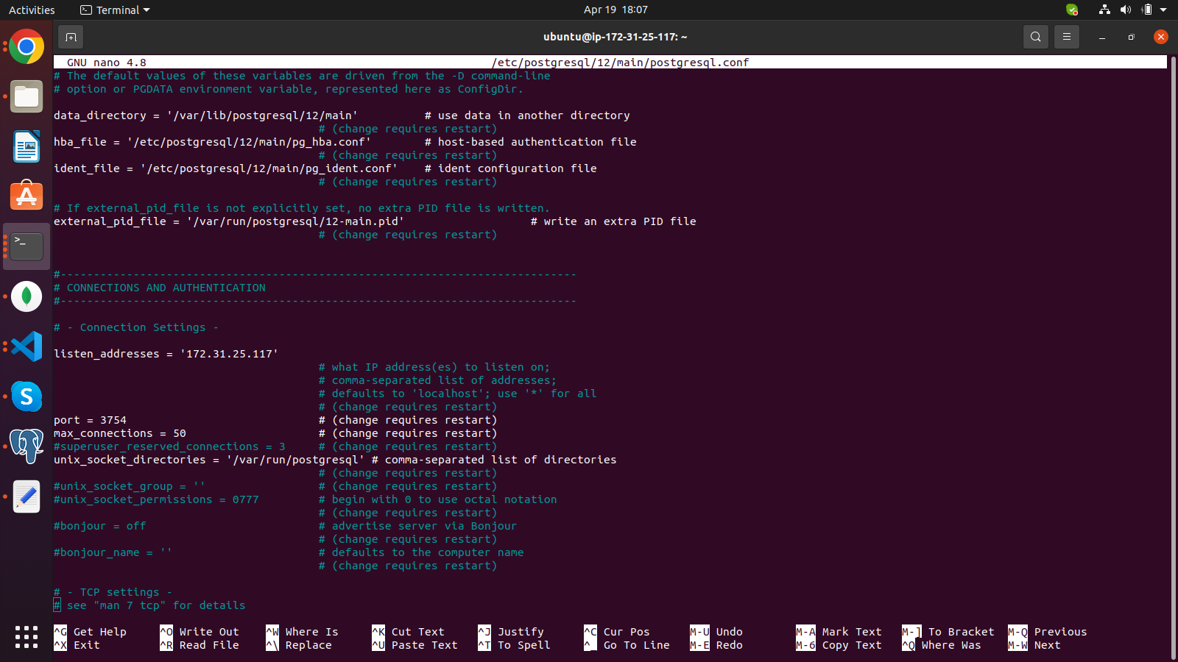

* after remote configuration run follwing command for restart services->
3) sudo systemctl restart postgresql.service
4) sudo systemctl status postgresql.service //----check it is in active state

